[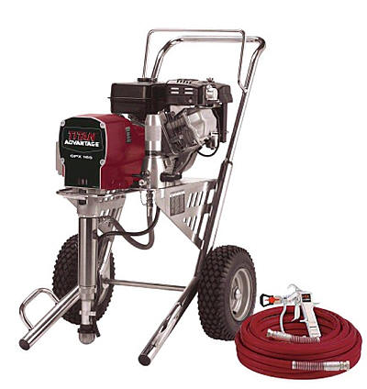](http://www.google.ca/url?sa=i&rct=j&q=&esrc=s&source=images&cd=&cad=rja&uact=8&docid=JQS3Wtdo4SKlFM&tbnid=r0-coKFR5kl19M:&ved=0CAUQjRw&url=http://www.paintsprayerslv.com/Titan/advantage_gtx.htm&ei=EdWtU8vsJ9bfsASViYKoDA&bvm=bv.69837884,d.cWc&psig=AFQjCNGFPM3glsdjegLd6M_cop5GX2QteQ&ust=1403987596626898)